Name:

Chapter 14: The Power of the Press
Type your answers in the boxes below each question.
Remember to RESTATE and use COMPLETE SENTENCES!
How were books made before the printing press?

What kinds of people knew how to read before the printing press?

Who “reinvented” the printing press?

Color the correct year that the printing press was first used to print books by using these tools from your toolbar: (highlight the year first)
1986 1094 1456 982
Why were so many Europeans excited about finding the Indies?

When you are finished with the questions, follow the links shown below to learn more!
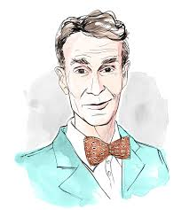
YOU HAVE TO HOLD DOWN THE CONTROL KEY AND CLICK THE IMAGE AT THE SAME TIME!
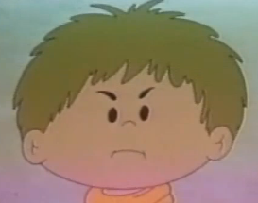

Next, Visit this site to learn more about the printing press.
(You need to hold the control key and then click the link)
Copy and paste 5 facts found on the website in the spaces below:
1.
2.
3.
4.
5.
Finally, control + click this AMAZING link to find a picture of a printing press to copy and paste into the space below:
You’re all finished! Please save your work and begin working on your survival narrative.

